Configuration Guide

Deviceworx xTag and xGateway Plugin

Powered by C-Labs C-DEngine™

A Guide for System Administrators

Revision Number 1610-009
January 6th, 2021

Table of Contents
Chapter 1 Introduction to C-Labs C-DEngine Plugins 3
1.1 Overview 3
1.2 About C-Labs Factory-Relay 3
1.3 About Plugins 3
1.4 Plugin Deployment Patterns 4
1.5 The Plugin Dashboard 5
Chapter 2 The Deviceworx xTag and xGateway Plugin 6
2.1 About the Sensors Gateways 6
2.2 Login 6
2.3 Accessing the plugin dashboard 8
2.4 Connecting to an xTag Sensor 8
Appendix A: Factory-Relay Navigation Icons 10

Introduction to C-Labs C-DEngine Plugins

Overview
This document covers configuring the DeviceWorx xTag plugin running on C-Labs Factory-Relay (and compatible platforms).

About C-Labs Factory-Relay
Factory-Relay provides remote and mobile access to industrial production equipment in a secure, efficient, extensible manner. In the interest of operational efficiency and reduced complexity, industrial systems are often configured with data security features disabled. With its built-in, IT-friendly data security settings, Factory-Relay seamlessly links production systems with office and mobile systems without compromising either factory operation or IT data security requirements.

About Plugins
A Factory-Relay plugin is a dynamic-link library (DLL) built with the C-Labs™ C-DEngine™ SDK. Plugins must have a filename with a prefix of “CDMy” or “C-DMy” (examples: CDMyCharts.dll and C-DMyNetwork.dll).

Plugins enable custom features in Factory-Relay or in any system built on C-Labs C-DEngine. The many types of plugins include:
- Configuration Plugins – provide a user interface for configuring hardware or software.
- Connector Plugins – enable a communication channel between C-DEngine network nodes, between sub-nets on a corporate network as well as between internet sites through compatible cloud nodes with support available for all major Cloud providers.
- Device Plugins – enable connections to and data collection from local sensors and devices directly connected to the system running C-DEngine.
- User Interface (NMI) Extension Plugins – provide custom controls and other user interface extensions to C-DEngine.
- Protocol Plugins – enables data collection using standard machine protocols like OPC / UA, Modbus, MT Connect, and data collection from proprietary programmable logic controllers (PLCs) such as the Siemens S7.
- Service Plugins – enables enhanced support for client-specific security protocols, proprietary algorithms, third party APIs, RESTful clients and servers, shared business logic or project-specific customizations.

As of this writing, available plugins number in the 100s while the total number of plugins that have been written number in the thousands.

Plugin Deployment Patterns
To simplify the proper plugin deployment and configuration, this deployment pattern applies to almost every plugin:
- Secure login – A username and password are required to log into Factory-Relay.
- Plugin button on home page – All plugins have a button on the Factory-Relay home page, the first page displayed when you log into Factory-Relay (see Figure 2.3). Click the plugin’s button to access the plugin dashboard.
- Plugin dashboard – A plugin dashboard displays all configured items (connections, object, devices, sensors). A plugin dashboard also has a button for creating new items (see Figure 1.1).
- Editing existing items – Configuring connections involves setting network or device addresses.
- Configure Properties – Once connections are established, you pick specific data points – also known as “properties” – to read.
- Things – In the world of connected objects, which is sometimes called the “internet of things”, C-DEngine participates in this paradigm through C-DEngine things.

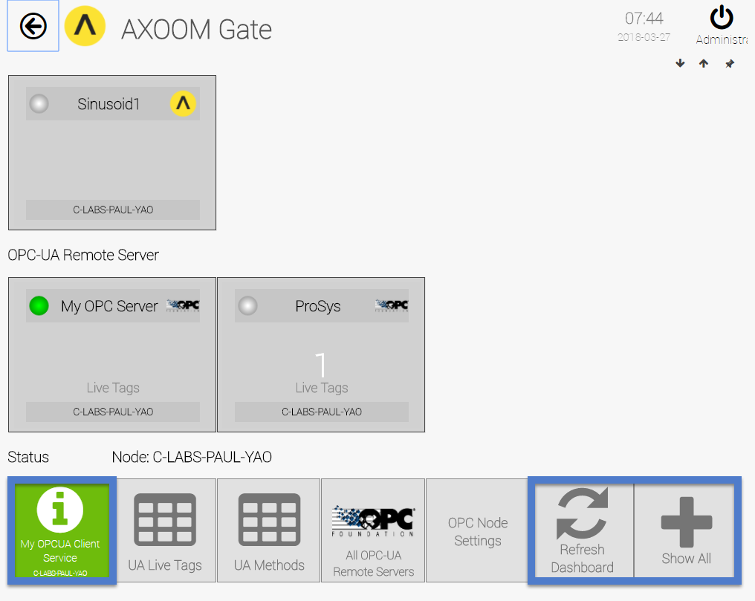
Figure 1.1. A sample plugin dashboard.

The Plugin Dashboard
A plugin’s dashboard (see Figure 1.1) provides the primary plugin interface. All “live” items appear at the top of a plugin dashboard. A set of buttons sits below the live items in the plugin dashboard. In the dashboard shown in Figure 1.1, blue rectangles identify the three buttons that are standard on every plugin dashboard:
1) About button: The button with the circled “I” is the About button. Click for details on the dashboard. The button color reflects the status. Status colors, associated status code, and meaning of the status are summarized here:
  - Gray (0): Idle.
  - Green (1): Active / Ok.
  - Yellow (2): Warning.
  - Red (3): Error.
  - Blue (4): Starting / Setup / Ramp Up.
  - Brown (5): Design / Engineering / Configuration.
  - Purple (6): Shutdown.
  - Black (7): Unknown / Unreachable.
2) Refresh Dashboard button: Reloads the dashboard with latest values.
3) Show All button: Open all forms and tables associated with the plugin.

Figure 1.2 shows the default image on a table button. Click a table button to view and edit a table of items managed by the plugin. For example, you can add new items, edit existing item properties, or delete items.
Figure 1.2. Buttons with this table icon enable viewing and editing tables of plugin items.

The Deviceworx xTag and xGateway Plugin
This chapter covers configuring the plugin to retrieve data from an xTag sensor, and includes the following topics:
- About xTag Sensors and xGateway
- Login to C-DEngine
- Accessing the plugin dashboard
- Adding connections to Modbus devices
- Accessing other settings groups
- The Device Status settings group
- The Connectivity settings group

About the Sensors Gateways
Deviceworx (deviceworx.com) provides two different products: sensor and gateways. Sensors collect data and send that data to a gateway. A gateway collects sensor data and forwards that data across a local area network (LAN) to either a local machine for collection and processing or to a Cloud-based system. A single xGATEWAY device can collect data from up to 10 Bluetooth-connected xTAG sensors and up to 20 USB-connected sensors.

The xGATEWAY comes with the C-Labs C-DEngine (“seed engine”) preinstalled. C-DEngine is a Rapid Development Framework for distributed Industrial-Grade IoT Solutions. Under development since 2009, the C-DEngine became open source in June 2020. C-DEngine provides xTAG and xGATEWAY with Microsoft Azure IoT Cloud connectivity out-of-the-box. Support for xTAG on xGATEWAY is provided by a plugin to C-DEngine for communication from both xTAG USB as well as xTAG Bluetooth. Solutions built on xTAG and xGATEWAY can be extended using the C-DEngine Software Development Kit (SDK) to enable customized integrations using any .NET-compatible language such as C# or Visual Basic.NET.

Login
From an internet browser, enter the URL for your login page. A login page appears (Figure 2.1).
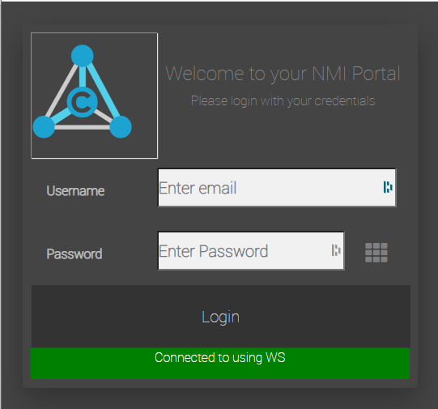
Figure 2.1. The dark scheme for the Factory-Relay login page.
You might have noticed that the login URL ends with /nmi. If you change that to /lnmi, the light scheme (see Figure 2.2) can used instead of the dark scheme.
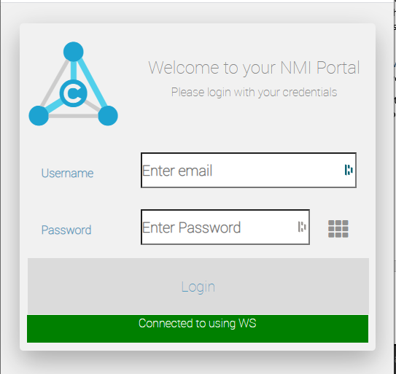
Figure 2.2. The light scheme for the Factory-Relay login page.
You see the Factory-Relay home page, as shown in Figure 2.3.
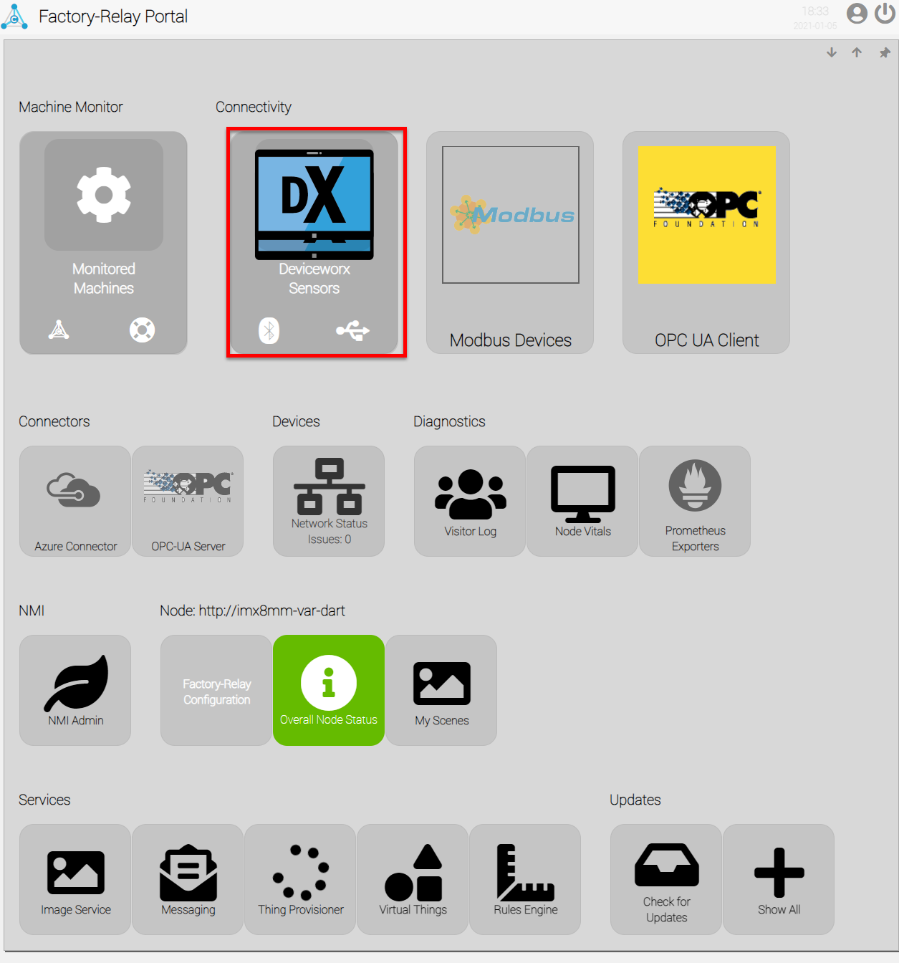
Figure 2.3. The Factory-Relay home page. The DeviceWorx Sensor plugin button is highlighted.

Accessing the plugin dashboard
When you click the Deviceworx Sensors plugin button, the plugin dashboard appears (see Figure 2.4).
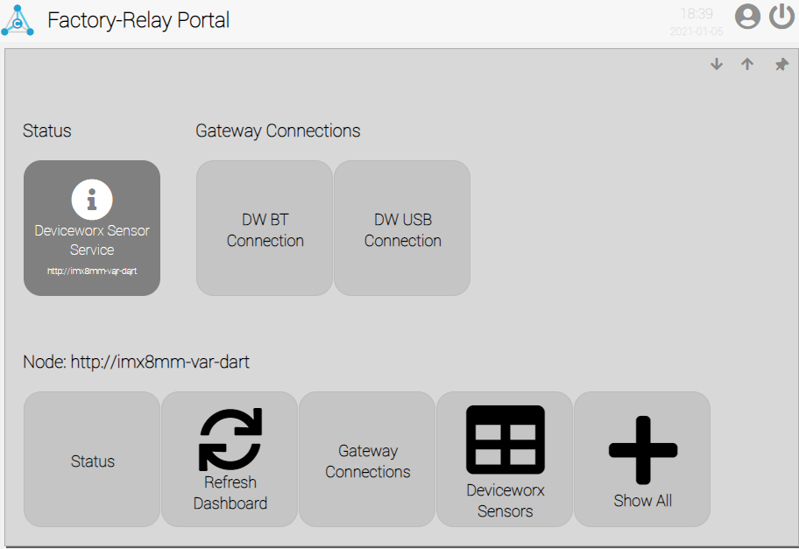
Figure 2.4. The DeviceWorx Sensor plugin dashboard.
There are two xTAG sensors connected: one Bluetooth xTAG and one USB xTAG.

Connecting to an xTag Sensor
From the plugin dashboard, click the DW BT Connection button to configure a Bluetooth sensor. The Bluetooth configuration page appears (see Figure 2.5). This configuration page has two parts: the left side shows the device status and the right-side shows device connectivity.
To configure USB sensors, click the DW USB Connection button. A configuration page appears for USB connections, which is like the one in Figure 2.5, except that the Bluetooth page is marked with “BT" and the USB page is marked with “USB”.
The Sensor Status Indicator. A round status indicator changes color when the sensor status changes. When the sensor is active, the status indicator is green. Other available colors and device status are shown here:
  - Blue: Starting / Ready to Connect
  - Green: Active / Ok.
  - Gray: Idle. Connected and Ready to Acquire data.
  - Yellow: Warning.
  - Red: Error.
  - Brown: Design / Engineering / Configuration.
  - Purple: Shutdown.
  - Black: Unknown / Unreachable.

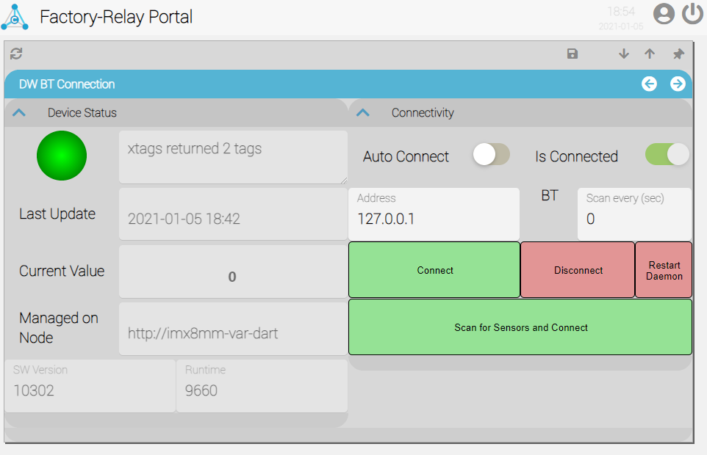
Figure 2.5. The Bluetooth Configuration page.

Scan for Sensors and Connect Button. To create the very first connection to an xTag sensor, click the button labeled Scan for Sensors and Connect.
Connect Button. Click the button labeled Connect for a Bluetooth device that has already been configured to work with the DeviceWorx gateway.
Disconnect Button. Click the button labeled Disconnect to sever the connection with the Bluetooth sensor.
Restart Daemon Button. The connection to an xTag sensor relies on a small piece of software, known as a “Daemon”, that enables communication from Factory-Relay to the sensor itself. If you have having trouble creating a new connection, or connecting with an existing device, you may need to click the
Restart Daemon button to reboot the software daemon.

Appendix A: Factory-Relay Navigation Icons
Here is a summary of the Factory-Relay navigation icons:
Icon | Name | Comments
 | Home | Click to navigate to home page.
 | Refresh | Use instead of the browser’s built-in refresh button.
 | Properties | Click to view properties.
 | Trash Can | Delete an item.
 | Up arrow. | Closes a group of controls.
 | Down arrow. | Opens a group of controls.
 | Left arrow | Decreases the width of browser space used to display property groups.
 | Right arrow. | Increases the width of browser space used to display property groups.

